# Networks and Communications – CO633

Lecture 1:

## Hardware

LAN – Local area network

WAN – Wide Area Networks

Packets – Information payload is in the form of a packets which are comprised of two parts (Header and Body)

WAN are usually Point to point links with no central point. A Wide area connection connects devices/LANs at different geographical Locations

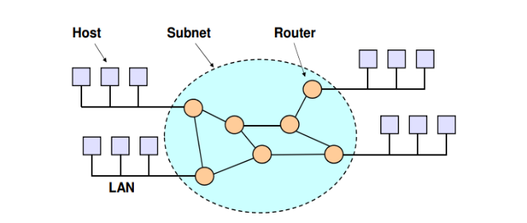Topology of WAN:  
Here we have 4 LANS connected to a WAN (central subnet circle via routers to go form point to point) which creates interconnectivity. The communication subnet is the fabric of the ‘WAN’ – referring to whole infrastructure of the WAN. Computers are called hosts in WANs terminology

## Network Software:

Network software is structured as a series of layers known as a protocol stack. Each layer builds on the one below and provides services to the ones above

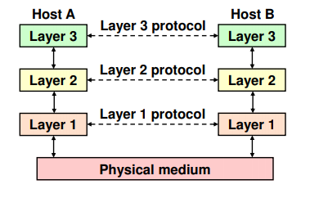Layer N on host A converses with its peer layer N on host B

The rules governing this exchange are called the layer N Protocol

Two standard models for network software:

* OSI (opten System Interconnect)
  + Non-standard, largely ignored by industry
  + Clean model provides good framework/references for discussing other systems
* TCP/IP (Transmission Control Protocol/Internet Protocol)
  + Originated with ARPANET (Pre-internet)
  + Widely used
  + Poorly defined model provides unsound basis for future development

OSI Reference Model is made up of 7 Layers

* Physical
  + Defines physical transmission medium and signals used
  + Unreliable connectionless service
    - If errors arise then they will not be corrected
    - Connectionless = packets are dispatched and routed independently (like postal system)
* Datalink
  + Reliable service – any errors that occur from the physical layer are detected and corrected automatically
* Network
  + Controls the operation of the subnet (how you might navigate the complexity of several routers within the subnet)
* Transport
  + True end-to-end later from source through to destination
  + Establish connection – transfer data – close connection
* Session
  + Provides services for session-based applications such as file transfers
    - Enables feature such as automatic recovery if connection failure
    - Such as continuing a download after interruption
* Presentation
  + Handles differences in the binary representations of data (common info)
  + Supports compression and encryption
* Application
  + Virtual terminal
  + Email, File transfer, streaming etc

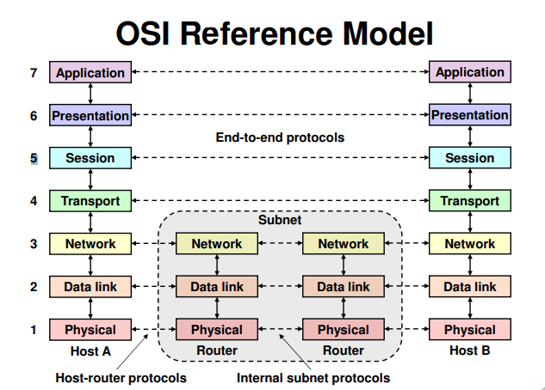The bottom 3 layers are often hidden/invisible

## TCP/IP

It’s made up of 4/5 layers. Lots of differences and similarities between TCP/IP and OSI

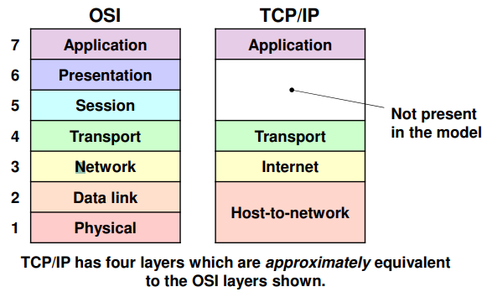

* Application
  + Numerous protocols are defined
    - HTTP, FTP, SMTP, DNS, ect
* Transport
  + Two end to end process-level protocols are defined:
    - TCP
      * Reliable connection-oriented protocol that delivers a byte stream with error correction
    - UDP
      * Unreliable, connectionless
* Internet
  + Defines a standard format for packets and protocol called IP
  + Connectionless delivery of datagrams between hosts
  + No guarantees about delivery or routing – Packets may be lost, duplicated or arrive in the wrong order
* Host-to-network
  + “A Great Void”
  + No standard protocol defined at this level
    - Good because it doesn’t care what its operating over as long as you implement the software API to do so
    - Meaning its not defined by explicit or bespoke hardware – it can run over anything if programmed to do so

# Lecture 2:

Transmission medium is a connection between two computers/devices

Data Rate = Number of bits transmitted / transmission time = bps

This is bits per second NOT bytes per second, so a conversion is required

Electronic signals travel at the speed of light

Data starts to arrive at receiver almost immediately so small amounts can be transferred almost instantly

Analogue Signalling – The amplitude of the signal signifies the data being sent measured in its oscillations – this translates to 1 and 0s depending on the signal amplitude of ‘high’ and ‘low’

You can split the levels in the analogue signal to have more than 2 values of high and low, and this can be used to increase the bit count sent in a single signal amplitude.

There are several things that can affect the signal – known as Attenuation and Distortion

* Electronic signals are attenuated (loose power) as they travel through a physical medium
* The shape of the signal can also become distorted

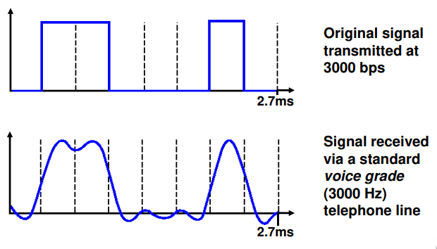Example of distorted but still readable data

We can still see which amplitudes represent a 1 or 0

As we increase the data rate we get more distortion – here’s the same signal but at a higher data rate as before

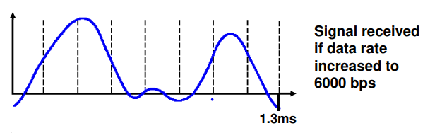Though it’s getting more ambiguous we can still reliably read which signals represent which types of data – though its not perfect

If we double the datarate again (this is done by reducing the time in which the data is being sent but still sending the same amount – effectively doubling the datarate) – we will certainly this time increase distortion amount and loose bits as the signal becomes flatter

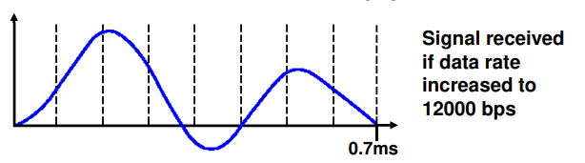Here we’re loosing information as its too distorted

Nyquist Limit (For Distortion)

* The amount of distortion and effect depends on the two main factors
  + Frequency Bandwidth (H) = difference between the highest and lowest frequencies
  + Number of discrete signal levels in use

The Nyquist limit gives the maximum safe rate beyond which distortion may cause data loss

Nyquist Limit = 2* H * log2(V) bps

2^1=2, 2^2=4, log2(8) = 3

Noise can also distort the signal

Noise is unwanted power from other sources that interferes with the signal during transmission, the three most common are:

* Thermal noise (White Noise)
  + Present in all systems cause by random motion of electrons
    - Can be improved with higher quality electronics
* Cross-talk
  + Signal from one cable or channel leaking into another
    - Can be improved with higher quality cabling
* Impulse noise
  + Intermittent bursts such as power surges, lightning strikes etc.

Noisy signals can look like the following:

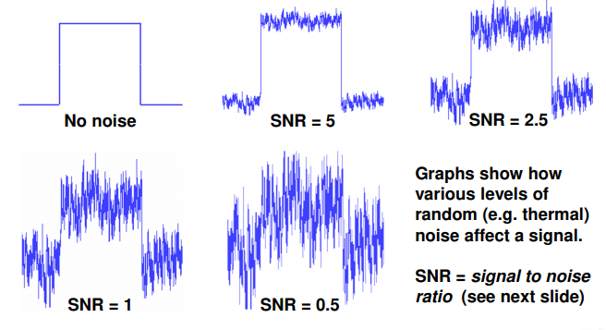This could be explained as thermal noise which each diagram showing a higher noise level

SNR = Signal to Noise Ratio

A higher SNR means the stronger signal to lower noise ration

A lower SNR means a lower signal to higher noise ratio as seen in the diagram

Again we can tolerate some amounts of noise but as it increases it gets more difficult to determine the data. There is a strong relationship between the amount of signal levels and potential data loss as we increase the steps in the signal (ie from 2 to 16) the differences are closer together so more susceptible to dataloss via distortion

## Shannon Limit

The amount of noise present on a physical connection is expressed by the SNR

SNR = Signal power / noise power

The Shannon limit (1948) gives the maximum safe rate beyond which noise may cause data-loss

Shannon limit = H * log2(1+ SNR) = bps

What is the Shannon limit for a telephone line with an SNR of 1023

= 30000

Shannon vs Nyquist limit = you choose the bottom of the two for the safe limit

# Transmission Media

Lecture 2/3:

Various physical media are used for the transmission of data. Each has its own niche in terms of capacity, Delay, security, Cost, etc.

Communication media can be divided into two categories:

* Guided Media
  + Guided media provide a conduit between two or more nodes. A signal travelling through such a medium is directed and contained within its physical boundaries (a cable or waveguide)
  + Coaxial Cable
  + Twisted Pair Cable
  + Fibre Optic
* Unguided Media
  + Wireless

## Guided Media

Twist Pair Cable

* 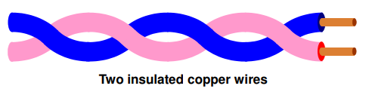Twisting reduces interference between adjacent cables
  + Wires twisted can carry equal or opposite currents along them so when interference is produced by the wires, they cancel each other’s interference out.
* Widely used or telephone systems and ethernet
* Bandwidth depends on wire thickness, quality of insulation and distance involved
* Several Mbps can be achieved over a few KM or higher over shorter lengths
* Reduces electromagnetic radiation and interference alongside the twisted pair cable from crosstalk between other neighbouring pairs

Category 3 and 5 UTP (Unshielded twisted Pair)

* 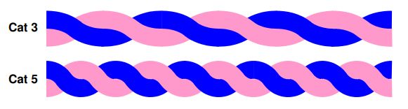Cat 5 has higher twisting; better insulation and the copper is of superior quality. This reduces attenuation, distortion and noise/interference. Hence cat 5 is better in most ways

Coaxial Cable (“Coax”)

* 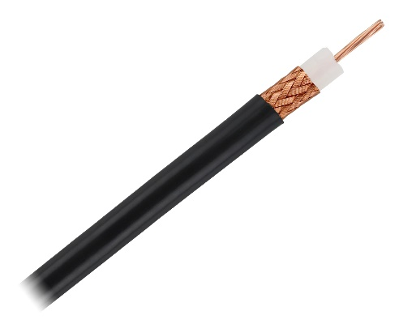Has superior shielding giving it a higher bandwidth and greater immunity to noise than twist pair cable
* 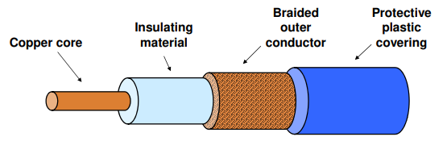Data rates of 1-2 Gbps possible over 1km

Fibre Optic

Somewhat like Coax in its method however it uses completely different materials

* 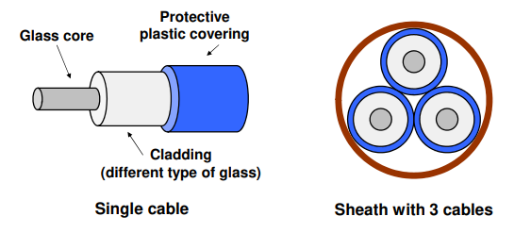IT contains a glass core which carries the data
* It then has a cladding layer which is made up of difference type of glass and is a perfect reflection to keep the light inside the cable
* We then have a protective plastic covering
* The Frequency bandwidth of optical cable is in the order of 100Thz (100,0 00 Ghz) which is a lot higher than electrical
* Fibre is often limited by the interface rather than the cable itself
* Rates up to 100Gbps are supported as of currently in commercial circumstances
* Higher rates can be achieved over long distances using ‘Dense Wavelength Division Multiplexing’ (DWDM) in which data channels are carried simultaneously over the same fibre by using different wavelengths of light
* Extreme data rates can be achieved using DWDM, rates of 100tbps over a 50km single-core fibre and 1Pbps via a 12-core fibre.

Fibre Optic Ring networks:

* 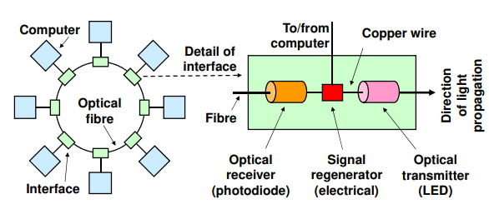Logically it’s setup as loop (ring network) but it doesn’t actually have to be laid out as such
* In most fibre networks, the signal only travels in a single direction
* In order, within the active repeater, the data comes in over the Fibre cable which then comes to the optical receiver in the interface, to which it then goes to a signal regenerator to boost and clean up the signal before its passed to the computer which then goes from the computer to the Optical Transmitter via a copper wire. The active repeater interfaces allow networks to be extended almost indefinitely
* Fibre optic cables are used for LANS and WANS
* A weakness of the ring topology of Fibre is that it often has a single point of failure within the ring, but to get round this a duel ring is often used, meaning there is two paths between any one computer so we essentially have a failsafe

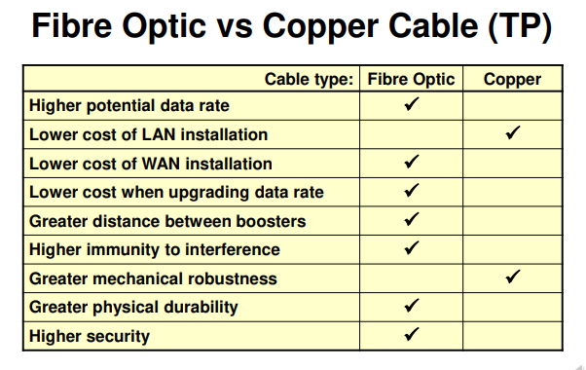Though Fibre is mostly superior, we can see a few advantages of using Copper.

* This mainly comes down to Cost (Interface and LAN costs)
* Mechanical Robustness (Fibre requires greater care when handling and requires more skill to install).

However for Wide Area Networks, Fibre is superior because using copper requires a lot of physical cable and over longer distances often used within WAN (Wide Area Networks) means fibre is more cost effective because of the Bandwidth vs Cost (so you technically need a lot less Fibre to carry the same amount of data as on Copper).

* Updating data rate is better with fibre because you only need to upgrade the interface and not touch the cabling at all.
* Fibre is better along greater distances because it requires less boosters and keeps the single strength higher over longer periods.
* Fibre also has a higher immunity to interference, alongside being a lot more durable overtime.
* Copper often is exposed to the elements and corrosion can occure a lot more on copper. Fibre can potentially last a lot lot longer than copper as its glass.
* And finally, Fibre Is a lot more secure because copper wires can emit radio waves which would technically allow someone to snoop on the waves.
  + In fibre you would need physical access to the cable, open the cable and cladding and have a device to detect the light – all without breaking the fragile core.

## Unguided Media

Wireless (Unguided Media)

* Mobile users require an unguided transmission medium
  + Electromagnetic spectrum
  + Radio waves
  + Microwaves
  + Infrared and Millimetre waves

Electromagnetic Spectrum

* 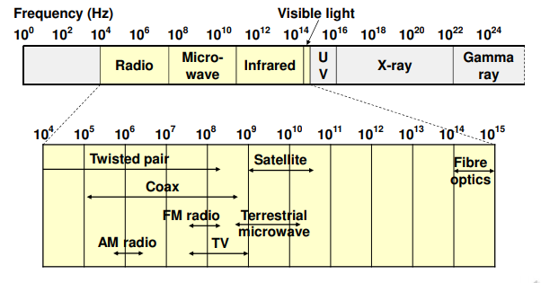The higher the frequency of the wave technically means the bandwidth is higher.
* Typically, we use bandwidths within the visible light spectrum due to radioactive issues with the higher Frequencies on the electromagnetic spectrum
* Easy to generate waves and can travel long distances
* Long range radio waves does mean that the issues of interference between different users can be a problem, along with electrical interference from other equipment.
* Often, a solution to excess waves being over everyone and interfering with each other is to adjust the transmission power so that the waves can only *just* reach their destination and not extend it or bleed around it.
  + This is what happens with mobile devices connecting to their radio towers
    - Power is adjusted based on distance

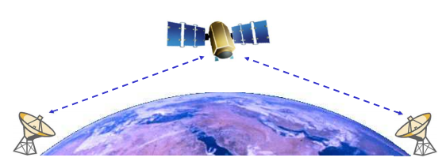  
High Frequency Radio Waves

* Wireless digital networks use high frequencies
* High frequency radio waves only travel in a straight line
* To extend such range, high towers and satellites are used with repeaters on them
  + This is due to the issue of radio waves being unable to travel through the ground

Microwaves

* 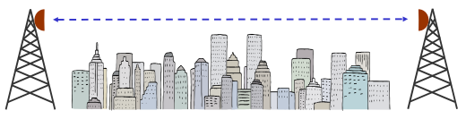Similar properties to High Frequency
* But an additional property means they can be focussed to a narrow mean using a parabolic antenna.
  + Improves signal/noise ratio but it requires the transmitter and receiver to be aligned accurately
  + Can be affected by bad weather (rain as water absorbed the microwaves) and cannot pass through obstacles. Often towers are high to transmit over buildings/obstacles

Infrared and Millimetre Waves

* Widely used for short range communication such as remote controllers and wireless data ports (IRDA) and some indoor wireless LANS
* Their inability to pass through solid objects reduces the likelihood of interference and makes it more secure
* However, infrared cannot normally be used outdoors
  + Due to infrared radiation from the sun it does not work outside
  + THE SUN IS VERY HOT DON’T GO OUTSIDE

Digital Communication via Telephone Networks

Public Switched Telephone Network (PSTN)

* PSTN was built for human speech which needs little bandwidth and can tolerate noise
* Although not ideal for digital signals, for some the PSTN is the only option available
* Much has been done to make digital communication via the PSTN as reliable and efficient as possible

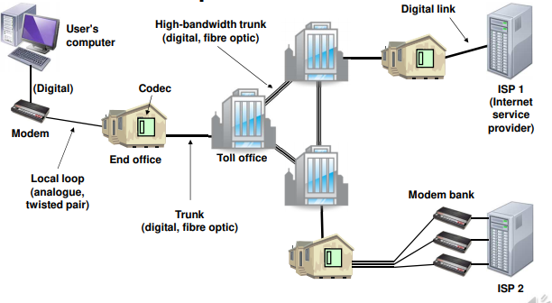

Main components of PSTN

Modems modulate waveforms for human speech so we can recognize them.

Modems (modulator demodulator)

Converts digital data to an analogue signal that can be transmitted efficiently via the local loop and vice versa

Data is encoded by modulating an analogue carrier signal

Typically a dial modem (v92) supports upto 56kbps using a combo of modulation techniques

How can we send multipule conversations across one cable? Multiplexing

Time division multiplexing allows a signle high bandwidth trunk line to carry multiple channels simultaneously

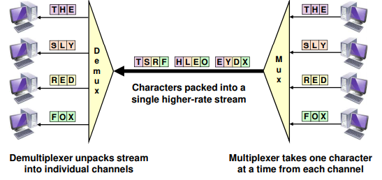

But how does the demultiplexor know which character to send to which receiver? This is done based on the orde. Even if no data is being sent by the sender, the channel allocation still needs to be made or the data will not be in order and the demultiplexor would mix up what goes where

Multiplexor can have lots of channels but in this example it shows 4 – one for each sender

Circuit switching

There’s no processing n the data between the connected calls so the latency is extremely low and often near the speed of light

Circuit vs Packet Switching

Setup is required before the data being transmitted can be received (i.e A telephone call can’t happen until the other end picks up the phone) Whereas with Packet switching the packets can just be sent and the receiving host can receive and interept when it wants.

With capacity on Circuits there is a finate amount – when all the lines are taken up then you cannt make the call whereas with Packets

Packet switching makes better us of resources as it is dynamically allocated as required during the call, whereas with Circuits there will always be X amount of lines so whether you’re talking or not on a given line it doesn’t matter as you’re still using the line

Circuits are charged per second whereas Packets are per packet

Digital Subscriber Lines (DSL)

Plain old telephone system:

* Frequency bandwidth limited to 3kHz but this is sufficient for voice
* Analogue signalling over local loop
* Dial-up modems are upto 56kbps
* Cost normally based on connection time

Digital Sub Lines (DSL)

* Currently most common broadband tech
* Bandwidth of local loop is cable is often much higher than 4khz
* Urban location where cables are short may be over 1Mhz
* DSL exploits full bandwidth of local loop cable (between phone and telephone exchange)
* Rates vary from 512Kbps to 24 Mbps depending on location
* Always fixed monthly charged
* Datarate can depend on distance from exchange
  + Also cable type

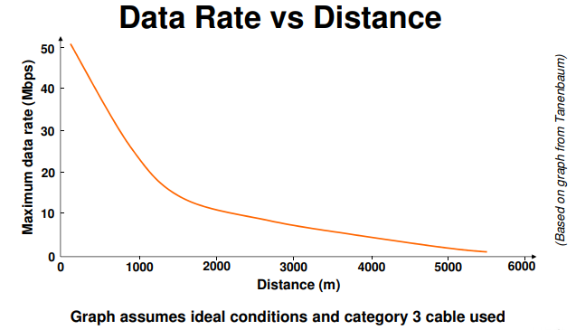

ADSL and SDSL

ADSL is aimed at home users, high number of channels for downstream and low number for ustream since most users download a lot more than they upload

SDSL is aimed at home users which gives a symmetric balance of the upstream and downstream

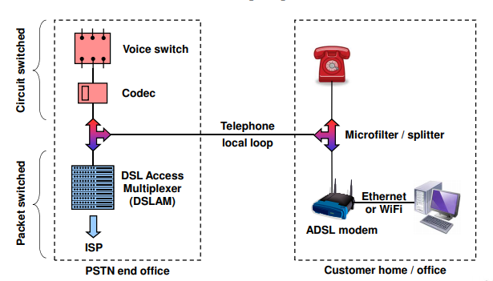SDSL is a lot more expensive due to the contention ratio as it’s a lot lower on SDSL since they are less businesses accessing the service so it doesn’t have to be split up as much compared to ADSL where you might have 50 people on a single line vs 5 on a business line

Fibre

FTTC (Fibre to the Cabinet) which is when the street cabinet less than 300m from the premises, at between the home and the cabinet is a copper wire and then fibre from the cabinet to the exchange . The copper cable used between the cabinet and home is short and thus can deal with the higher bandwidth

FTTB (fibre to building) which is exactly the same as FTTC but the cabinet is inside the building

FTTH (Home) gets rid of the copper and typically provides upto 300Mbps for domestic customers or upto 1Gbps for business customers.

# Mobile Networks

Several generations:

* 1G: Analogue voice (1984, obsolete)
* 2g: digital voice (1991, legacy technology but still in use)
* 3G: Digital voice, multimedia and data (2002 but still used)
* LTE (3.9Ghz)

Cellular Structure

* The geographic region is divided into cells
* At the centre of each cell is a base station
* Base stations are connected directly to switching offices
* Mobile phones communicate with nearest bas station via short range radio channel
* Benefits of cellular structure include increased capacity and reduced power usage
* Having more stations rather than one large one allows for a higher capacity
* Having more smaller stations potentially reduces the distance and requires less power to connect to the nearer, smaller station
* In the countryside you may find phones drain battery quicker due to needing more power to connect to less, further away stations

2G and 2.5G:

* Bandwidth is split into hundreds of narrow channels (FDM) each capable of carrying several telephone calls (TDM)
* Basic 2G Dial-up service offers just 14.4 Kbps for data
* Enhanced 2G services (2.5G boost)
  + GPRS (general Packet Radio Service)
    - Packet switched service overlaying 2G system
    - Phone with data packets to transmit first notifies base station
    - Base station allocates channels and time for transmission
    - Maximum data rate typically 44Kbps
  + EDGE (Enhanced data rates for GSM evolution
    - Faster Bit rate per channel
    - Can boost GPRS data rate up to 384 Kbps

3G

* Global standard (almost)
* UMTS (universal Mobile Telecommunications system)
* Uses CDMA channel access method to achieve higher data rates than possible with 2G Systems
* Max data rate dpends on speed of user
  + Stationary : up to 2Mbps
  + Walking: upto 384kbps
  + Driving in car: upto 144
    - Why does moving affect this?
    - As you’re moving at speed its difficult to constantly switch between tower stations and retain a higher speed
    - Alongside with general interference from other objects while moving, such as buildings

Enahnced 3G Services: (3.5/3.7G)

* HSDPA (High Speed Downlink Packet Access)
* HSUPA (High speed uplink packet access)
* HSPA+

LTE (3.9G / Pre 4G)

* Full name is 3G Partnership project
* Pre 4G but marketed as 4G
* Better than 3G but not quite as good as 4G
* Key Characteristics:
  + Uses orthogonal Frequency-Division Multiple Access instead of CDMA
  + Copes better with fast motion than 3G
  + Supports full IP operation with low latency and end-to-end QoS
  + Uses different radio bands to 3G
  + Has evolved over the years
* LTE has cat Numbers but not the same as cabling cat numbers
* Data Rates: (download/upload)
  + LTE 1: 10Mbps/5Mbps
    - Slower than 3G? 3G was throttled initially to make this seem faster!
  + LTE 2: 50 Mbps /25 Mbps
  + LTE 3: 100 Mbps/50 Mbps
  + LTE 4: 150 Mbps/ 50 Mbps
  + LTE 5: 300 Mbps/ 75 Mbps
    - Speeds are not always as what they seem as providers often throttle due to many factors including user load

True 4G

* Tech that meets minimum req for 4G specified by the international standards body known as “True 4G”
  + True 4G offers upto 1Gbps to pedestrians and stationary users and upto 100Mbps to users travelling at speed
* Essentially a higher speed mobile broadband system that supports IP Telephones and multimedia streaming as well as data
* Two True 4G techs have been developed
  + LTE Advanced (LTE-A)
  + Mobile WiMAx release 2

LTE Advanced

* Data rate is boosted by better MIMO (more than one antenna in a mobile device) carrier aggregation (several frequency channels/bands use in parallel to send/receive data and
  + Beam-forming (if you’re using several antennas you can direct the energy to the radiowaves in one direction rather than ‘everywhere’ – this means a stronger signal to noise ratio and less interference from other devices. Beam-forming also boosts capacity
* Performance at Cell edges is improved by Coordinated MultiPoint (coMP) techniques which allows a mobile device to use two ore more base stations simultaneously allowing for a higher data rate spread across more than one base station
* Data Rates:
  + Cat 6: 300 Mbps/ 50 Mbps
  + Cat 7: 300 Mbps/ 100Mbps
  + Cat 8: (Cell = 3000 Mbps) and Single User = 1200 Mbps) and uplink is cell=1500 Mbps and single user = 600 Mbps

LTE Advanced Pro (4.5G/ Pre 5G)

* Marketed as 5G!
* Key enhancements include:
  + Greater network capacity
  + Increased data rate, upto 3Gbps
  + Low latency, 2ms vs 10ms for LTE-A
    - Big improvement as it allows for more advanced technology to be streamed over the network, such as video-game streaming and driverless cars
    - Deployment in major cities in 2019 but still several years off wide coverage

True 5G:

The goal is to create a universal wireless communication system that supports a wide variety of devices

Objectives include:

* Increased coverage to 100%
* Boost peak data rate to 10Gbps
* Reduce end to end latency to 1ms
* Reduce power consumption by 90%
* Support 10-100 times as many connected devices

It may use several technologies to achieve this, such as satellite uplink for more remote areas or some kind of global satellite array (Elon Musk?)

# Data Link Layer

The datalink layer turns a raw transmission medium into a reliable communication channel

* Data Communication techniques
  + Framing
  + Error Detection
* Control protocols
  + Flow control
  + Error Control
  + High-level data link control

Data Link layer features

* Operates between directly-linked devices
* Turns raw transmission medium (physical layer) into a reliable communication channel
* Provides well-defined services to network layer:
  + Encapsulates data into frames
  + Handles detection and correction of transmission errors
  + Regulates the flow of data
  + High-level link management

Service Types:

* Unacknowledge connectionless (CL)
  + Frames are transmitted independtly
  + Receiver may detect errors but there is no recovery (Like TCP/IP)
  + Send not notified whether transmission succeeded or failed
* Acknowleged connection-orientated
  + A Logical connection is established (potentially a software based connection on X port)
  + Each frame has a unique sequence number
  + Receiver acknowledges receipt of each frame
  + Sender retransmits frame if damaged or lost
  + Protocol guarantees all frames are delivered successful in the correct order nd without duplicates

## Framing:

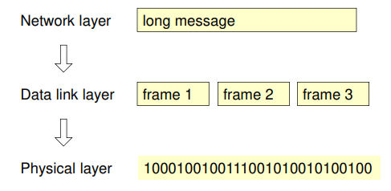The sendrs data link layer splits the data stream from the network layer into rames for transmission via the physical layer (FRAMES are more or less exactly the same as Packets, just named differently in this circumstance)

The Receiver’s data link layer reverses this process (i.e. raw bit stream -> frames -> long message)

It must therefore be able to:

* Identify where each frame begins and ends
* Extract and process the contents of each frame

This may be difficult because:

* Frames are subject to noise and impairments during transmission
* Noise may also be present in the gaps between frames

Byte Count:

One very simple framing techniques is to record the length (N) of a frame at its start



If we have errors, how can we detect them without ruining the rest of the bytes?

Flag Bytes with Byte Stuffing:

* Assists with resynchronisation after an error
* Frames start and end with a special flag byte
* The Flag byte value corresponds to a special character which is unlikely to occur in textual data
* Robust however at its worst it can double the length of the data with all the escapes added in

Check back to lectures to understand this better

# Error Detection and Correction

* Noise, Interference and attenuation an result in bits being altered or lost during transmission
* Rnadom bits may be corrupted in isolation or whole groups of adjacent bits affected together
* Qireless networks and PSTN local loops are pertialry prone to transmission errors
* Errors may be tolerated for some forms of communication
* However error detection and orrect are essential for most computing applications

Error-detecting codes

* An Error-detecting code (check bits) is normally added near the end of each frame, e.g.
* Code generate by sender before transmission based on a calculation involving all of the data
* Sometimes there’s a chance that the corrupted bit could actually be the error-detecting code itself
* Receiver performs same calculation after transmission and compares the result with code in frame, if the two values differ then data bytes probably contain an error

Modular Checksum

* Aka sumcheck
* 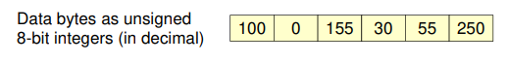A simple error-detecting code calculated by summing the values of the dta bytes as unsigned integers and discarding any overflow

Most widely used error detecting code is known as Cyclic Redundancy Check (CRC)

The capabilities of CRC will be examined on for comparison against other methods

* A hash code that’s highly effective for detecting errors
* Widely used in network and data storage tech
* CRs are typically 16 or 32 bits long
* A properly designed N-bit CRC will detect
  + All single-bit errors
  + All double-bit errors
  + All odd numbers of bit errors
  + All error burts in <= N bits
  + Most error burts > N bits
* CRCs also detect a variety of other errors including extra zero bytes and changes in the order of bytes

Forward Error Correction:

# Data Link Control Protocols

Control protocols coordinate the exchange of data through a communications link and also the management of the link itself. Typically provide a reliable connection-orientated service over a duplex link

* Flow Control
  + Stop-and-wait
  + Sliding window
* Error Control
  + Stop-and-wait ARQ
  + Go-back-N ARQ
  + Selective-reject ARQ

Stop and Wait Flow Control

* Flow control allows the receiving device to limiter the rate at which frames are sent
* Stop-and-wait is the simplest approach:
  + Sender transmits a data frame
  + Receiver accepts data frame
  + When receiver ready for another data frame it transmits a receiver ready (RR, aka ACK) frame
  + 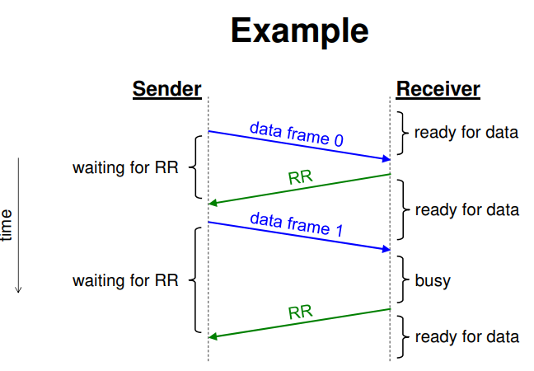Sender waits for RR before sending next data frame

Sender sends its first frame, when the receiver is ready for more it sends an RR, the sender then sends another data frame however this time the receiver is busy so the sender waits for RR before sending more data, at which the receiver then sends the RR ready for more data

Full Duplex – Data can flow both ways simultaneously

Half Duplex – data can flow both ways but only one way at a time

The example above can work with either Half or full duplex but generally Full duplex is better

## LAN Efficiency example

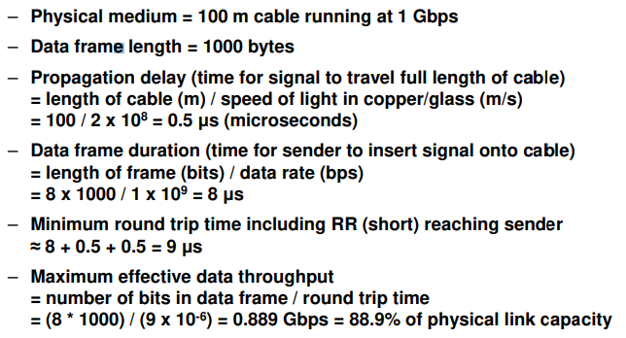

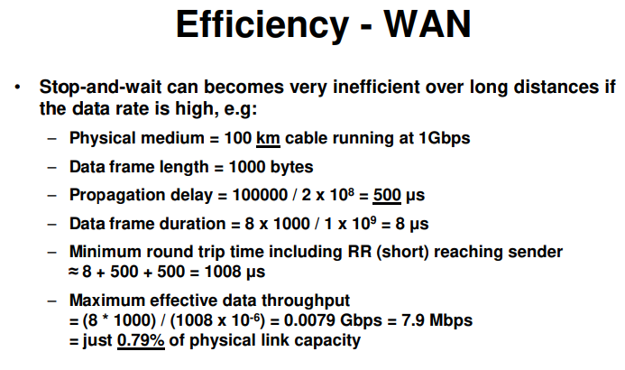

Essentially, Stop and wait is great for short LAN networks but bad for long distance WAN connections as the stop-and-wait protocol timings grow with the cable length

In sliding window, it doesn’t wait for the acknowledgement thus only works over a full duplex connection.

Selective-Reject ARQ